Fish Assessment of Two Lick Creek and Yellow Creek Watersheds:
Introduction
Two Lick Creek is a stream located in Indiana County that is the largest tributary of Blacklick Creek at roughly 190 sq. mi., who begins its course in Green Township and heads west and southward to its mouth in Josephine before entering Blacklick Creek. The stream’s largest tributary is the Yellow Creek watershed. The primary land uses are forest, agriculture, urban areas, and residential areas, with forest and agriculture comprising the majority of land cover at roughly more than 80% of the land cover (1). The watershed comprises several developed areas including the cities of Indiana, Clymer, and Homer City. The Two Lick Creek watershed supports a variety of sports fishing species including Brown Trout, Rainbow Trout, Brook Trout, Smallmouth Bass, Largemouth Bass, and Yellow Perch. Abandoned mine drainage (AMD) is a leading impairment of streams in the watershed with notable discharges including Richard’s, Penn Hills, Risinger, Yellow Creek discharges, Lucerne discharges, and more (2). Fish serve as important indicators for long-term water quality monitoring, due to their continued presence in water and their sensitivity to pollution and habitat degradation. Thus, an index of biotic integrity based on the Ohio EPA protocol can be used to assess stream health and determine impacts to a watershed using fish (3).
The Richard’s treatment system has reached its life span and is to be rehabilitated in 2020. Determining the effects of the Richard’s discharge on fish and macroinvertebrate communities in Two Lick Creek is currently unknown and needed to assess the restoration impact of the Richard’s treatment system. Secondly, an assessment on the impacts of AMD beginning near Route 954 is needed to restore the water quality and stream health on Yellow Creek. Lastly, baseline data of fish is needed to assess the state of the Two Lick Creek watershed and provide above/below impacts from main sources of AMD discharges (Richard’s, Penn Hills, Risinger/Yellow Creek). Thus, the purpose of these surveys were to assess the impact of the Richard’s discharge on Two Lick Creek, the impact of AMD on lower Yellow Creek, and to provide baseline fish data for Two Lick Creek.

Methodology
Water Chemistry
A multimeter was used to take pH, conductivity, and temperature measurements. Alkalinity was taken at sites where applicable. Additional water chemistry information was pulled from previous water sample analyses including Hedin Environmental’s Yellow Creek sampling.
Fish Survey
Fish Surveys were completed on a 100 meter section of stream using a Smith-Root LP-24 electroshocker backpack. Surveys were completed in July of 2020. Shocking time ranged from 20-70 minutes and shocking voltage dependent on for each stream. Fish were identified in the field. An index of biotic integrity was completed according to the Ohio EPA’s fish IBI protocol.
Macroinvertebrate Survey
A macroinvertebrate survey was completed by measuring a 100 meter distance using a dipnet. Surveys were completed in April of 2020. Twenty kicks were completed over the survey distance. Kicks consisted of twenty seconds of constant kicking in a 1 square meter area upstream from the dipnet. After collection, large debris was washed clean of any invertebrates and removed. The remaining material was collected within a 500 mL container and filled with 90% isopropyl ethanol for preservation. A subsample was identified from the collected material using a 24 gridded pan with a random number generator to search a square until 200 individuals are identified. An index of biotic integrity was completed according to the DEP’s analysis protocol (4). A macroinvertebrate survey was completed above and below the Richard’s treatment system.

Results
Two Lick Creek
Two Lick Creek above the Richard’s Treatment System had a fish IBI score of 46 and a macroinvertebrate IBI score of 71.82, meeting the definition of a warmwater fishery and the classification of a trout stocked fishery. Wild Brown Trout were present in the stream, thus, meeting the definition for a trout stocked fishery classification. Based upon a simple visual assessment, habitat appeared quite abundant with plenty of unembedded cobble and boulders, a good frequency of pools, riffles, and runs, snags, undercut banks, and sand/gravel. The field water chemistry measurements had a pH of 8.03, temperature of 20.4°C, alkalinity of 130 mg/L, and a conductivity of 384 µS/cm³.

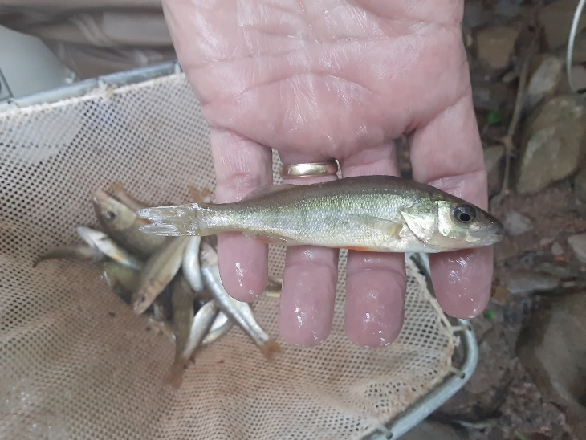
Figure 1. Yellow Perch (Perca flavescens)
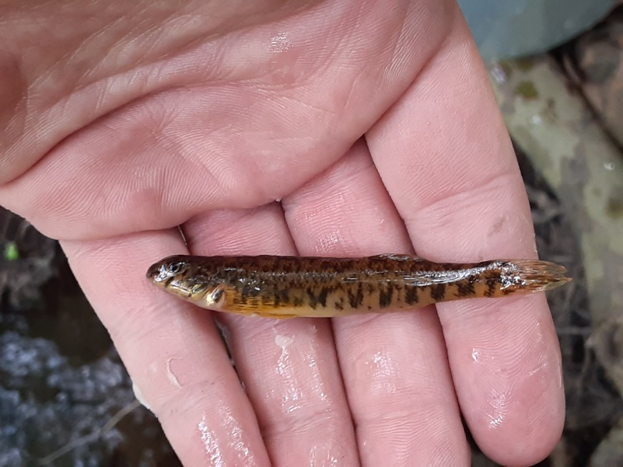
Figure 2. Johnny Darter (Etheostoma nigrum)

Two Lick Creek below the Richards Treatment System had a fish IBI score of 40 and a macroinvertebrate IBI score of 66.29, meeting the definition of a warmwater fishery. Brown Trout (young of the year) were present in the stream, thus, the stream meets its classification of a trout stocked fishery and indicates reproduction is occurring. A total of 15 species were collected. Mottled sculpin were the dominate species at 54% of the sample. Based upon a simple visual assessment, there appeared to be plenty of fish habitat with cobble, boulders, snags, riffles, pools, and runs. However, the stream appeared to have issues from sedimentation from the Richard’s discharge and silt. The field water chemistry measurements had a pH of 7.76, temperature of 19.5°C, conductivity of 440.6 μS/cm³, and an alkalinity of 156 mg/L.
Two Lick Creek below the Two Lick Creek Reservoir, at Waterworks Conservation Area, had a fish IBI score of 37 and meets the definition of an impaired warmwater fishery. A total of 12 species were collected. The stream possessed wild Brown Trout, indicating good water quality, thus meeting its classification of a trout stocked fishery. Mottled sculpin were the dominate species, comprising 63% of the sample. There appeared to be a lack of fish habitat, based upon a simple visual assessment, within this section. There were a few deep pools, large boulders, and some cobble present, however, it was not at a level that would be expected for this size of stream. Smallmouth bass were also present within this section and would serve as additional game fish for this area. The water chemistry had a pH of 7.2, temperature of 13.2°C, conductivity of 230 μS/cm³, and a TDS of 115 mg/L/.
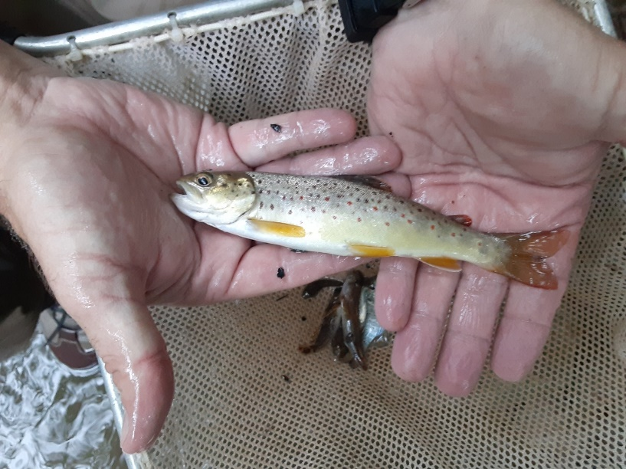
Figure 3. Wild brown trout (Salmo trutta)

The Two Lick Creek mouth had a fish IBI score of 44 and meets the definition of a warmwater fishery (Ohio EPA, 1987). A total of 14 species were collected. Banded darters were the dominate species, comprising 47% of the sample. The stream was comprised of 6 darter species, who comprised the majority of fish, including the logperch. No trout were found in this stretch of stream, but the stream could likely serve as a trout stocked fishery, thus meeting its stream classification. The stream, based on a simple visual assessment, has plenty of habitat for fish including cobble, gravel, pools, snags, riffles, runs, and large woody debris. The stream had visual impairments from AMD, including iron deposition and aluminum hydroxide hue. However, the water chemistry indicated good water quality with a field pH of 7.35, conductivity of 523 μS/cm³, a temperature of 22.3°C, and an alkalinity of 52 mg/L.

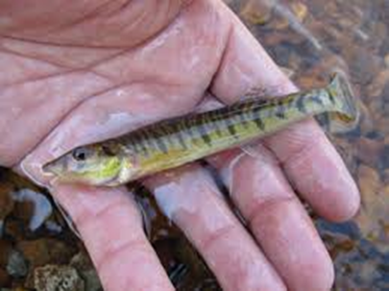
Figure 4. Logperch

Yellow Creek
Yellow Creek just above Route 954 scored an IBI of 30 and meets the definition of an impaired stream. The stream had a total of six fish species collected. River chubs were the dominate fish species, comprising 57% of the sample. River Chubs are a strong indicator of a healthy stream being a pollution intolerant species, insectivorous, and simple lithophil. The stream did not have a formal habitat assessment, but a visual inspection suggests the stream has plenty of habitat with a high frequency of riffle, pool, and run habitats, unembedded boulder and cobble, gravel & sand for reproduction, snags, and undercut banks. Water chemistry had an acidity level of -31 mg/L, a pH of 7.4, alkalinity level of 37, iron level of <0.18 mg/L, aluminum level <0.3 mg/L, manganese level 0.06 mg/L, and sulfate level of 45 mg/L.
No fish were present near the mouth of Yellow Creek at Floodway Park. Based upon a simple visual assessment, there appears to be habitat for fish including boulders, cobble, gravel, sand, and woody debris. Water chemistry lab results show Yellow Creek at Floodway Park had an acidity of 9 mg/L, a pH of 6.3, alkalinity level of 13 mg/L, an iron level of 16.3 mg/L, an aluminum level of 4.0 mg/L, a manganese level of 0.7 mg/L, and a sulfate level of 192 mg/L. A macroinvertebrate survey needs to be completed, which will provide further clarification of water quality through biotic integrity analysis.

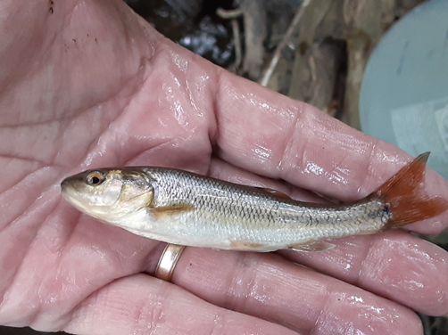
Figure 5. River Chub (Nocomis micropogon)

Table 3. Fish & macroinvertebrate Index of Biotic Integrity (IBI) scores of Two Lick Creek watershed
sample sites

Location | Fish IBI Score | Macroinvertebrate IBI Score
Two Lick Creek Above Richard’s T.S. | 46 | 71.82
Two Lick Creek Below Richard’s T.S. | 40 | 66.29
Two Lick Creek Below Reservoir | 37 | N/A
Two Lick Creek Mouth | 44 | N/A
Yellow Creek Above Rt. 954 | 30 | N/A
Yellow Creek Mouth (Floodway Park) | N/A (No fish present) | N/A

Analysis & Conclusion
Two Lick Creek:
Two Lick Creek Above Richards Treatment System:
Based upon the fish and macroinvertebrate IBI, Two Lick Creek above the Richard’s Treatment System is attaining at a level with its designated use of a trout stocked fishery and also meets the definition of a warmwater fishery classification. Two Lick Creek may support wild trout populations as evidence by wild trout and young of the year caught in this survey downstream of the North and South Branch, thus potentially extending the range of PFBC’s wild trout designation for Two Lick Creek. There is a healthy population of macrionvertebrates and fish, with several sensitive indicator species and good diversity. The stream appears to be healthy and of good water quality with water chemistry parameters in good standing, strong biotic integrity, good habitat, and little encroachment or environmental impacts.
Two Lick Creek Below Richards Treatment System:
The Richard’s discharge does impact the Two Lick Creek biotic integrity, with a decrease of 6 points in the fish IBI score and 5.53 points in the macroinvertebrate IBI score compared to above the Richard’s discharge. The fish community was similar in composition to that above the Richard’s discharge, aside from a few species comprising a minority of the population. However, there appeared to be a decrease in species abundance across both the fish and macroinvertebrate community, with more pollution tolerant species abundance increasing. Thus, these findings further support the conclusion that the Richard’s discharge is impacting Two Lick Creek. While the stream scored lower below the Richard’s discharge, Two Lick Creek is still attaining at a level that meets the definition of a warmwater fishery classification and its scoring doesn’t rescind its designated use as a trout stocked fishery. Restoration of the Richard’s treatment system is likely to improve the fish and macroinvertebrate communities to a level such as that above the discharge.
Two Lick Creek Below Reservoir (at Waterworks Conservation Area):
The stream fell within the impaired warmwater fishery classification based upon the fish IBI, however, it was relatively high and may have just fallen out of the attaining range. The stream appears to have a good water quality based upon field data, with an acceptable pH, low temperatures, and reasonable conductivity levels for the watershed. Despite having the greatest fish count, the location appeared to have little habitat for fish and possibly channelized based upon aerial imagery. This may explain why fewer species were found. Compared to a survey done at a similar location in 2006 by Dr. William Brenneman, four similar species were found in both surveys and five new species were discovered in our survey (2). Wild brown trout were discovered in both surveys, supporting their early findings of a resident wild trout population. A macroinvertebrate survey would help to clarify the IBI score and stream health, yet, I would recommend moving the sampling site for future samplings further downstream where more habitat may exist.
Two Lick Creek Mouth:
The stream meets the definition of a warmwater fishery, which would be expected for a stream of this size. The stream may serve as a trout stocked fishery (though no trout were found) that it would therefore not change its designated use. Abandoned mine drainage issues appear to impact the stream from upstream discharges (Yellow Creek, Risinger Discharge, and Tearing Run) with metal loading and sedimentation. A macroinvertebrate survey needs to be completed at the Two Lick Creek mouth, which will provide further clarification of water quality through biotic integrity analysis. Restoration of these AMD discharges will likely result in significant improvements on the lower Two Lick Creek watershed. The Blacklick Creek also poses issues for the lower Two Lick Creek watershed as a barrier for fish migration. Restoration in the Blacklick Creek watershed, notably with the development of the treatment plant for the 3 Sisters/Wehrum/Red Mill discharges, will also likely have significant impacts in improving the fish community of the Two Lick Creek watershed.
Yellow Creek:
Yellow Creek Above Route 954:
The high pH (>7.0), low acidity levels, low metal loadings, moderate alkalinity, and good habitat would suggest suitable habitat for many fish species. Also, the presence of intolerant species such as River Chub, who dominated the species composition, would suggest good water quality. However, the low IBI score and low diversity suggest the stream is impaired from a biotic integrity analysis. This impairment may be due to the AMD below Route 954 creating a barrier for fish to migrate upstream, thus creating a low IBI score. A macroinvertebrate survey will clarify whether the biotic integrity confirms this hypothesis or reflects the indication of impairment, as macroinvertebrates are not subjugated to migration impairments to the degree fish are.

Yellow Creek at Floodway Park:
The lack of fish is most likely due to AMD impairment, which the water quality of the stream is degraded through iron & aluminum loading, and sedimentation from precipitates. All of which are known to contribute to the absence of fish. The stream appears to support good habitat for fish that upon AMD restoration, fish would be expected to return to the stream. A macroinvertebrate survey needs to be completed, which will provide further clarification of water quality through biotic integrity analysis.

References
- Two Lick Creek Indiana County: Water Quality Standards Review, Stream Redesignation Evaluation Report. 2016. Department of Environmental Protection.
- Two Lick Creek Coldwater Heritage Conservation and Restoration Plan. 2005. Ken Sink Chapter of Trout Unlimited. Cold Water Heritage Partnership of Pennsylvania.
- A Benthic Macroinvertebrate Index of Biotic Integrity for Wadeable Freestone Riffle-Run Streams in Pennsylvania. 2012. Department of Environmental Protection. Division of Water Quality Standards.
- Biological Criteria for the Protection of Aquatic Life: Volume II: users Manual for Biological Field Assessment of Ohio Surface Waters. 1988. Environmental Protection Agency: State of Ohio. Division of Water Quality Planning & Assessment: Ecological Assessment Section.

Tables & Figures

Table 1. Fish survey results in Two Lick Creek watershed
Species | Two Lick Creek Above Richards | Two Lick Creek Below Richards | Two Lick Creek Below Reservoir | Two Lick Creek Mouth | Yellow Creek Above Rt. 954
Creek Chub | 7 | 1 | 0 | 0 | 1
Blacknose Dace | 1 | 2 | 11 | 0 | 0
Emerald Shiner | 4 | 7 | 0 | 0 | 3
Bluntnose Minnow | 1 | 1 | 4 | 2 | 0
River Chub | 3 | 8 | 0 | 1 | 65
Northern Hogsucker | 3 | 2 | 16 | 2 | 4
White Sucker | 17 | 5 | 3 | 6 | 0
Fantail Darter | 1 | 1 | 0 | 11 | 0
Blackside Darter | 4 | 3 | 0 | 0 | 0
Rainbow Darter | 7 | 11 | 7 | 5 | 0
Greenside Darter | 1 | 1 | 0 | 10 | 3
Johnny Darter | 5 | 0 | 2 | 7 | 0
Logperch | 0 | 0 | 0 | 3 | 0
Banded Darter | 0 | 0 | 0 | 50 | 0
Yellow Perch | 2 | 0 | 0 | 0 | 0
Green Sunfish | 0 | 0 | 1 | 3 | 0
Pumpkinseed | 1 | 0 | 1 | 0 | 0
Bluegill | 4 | 0 | 1 | 4 | 0
Smallmouth Bass | 0 | 1 | 1 | 2 | 0
Yellow Bullhead | 1 | 2 | 0 | 1 | 0
Brown Trout | 2 | 1 | 1 | 0 | 0
Mottled Sculpin | 23 | 54 | 80 | 0 | 38
Total | 87 | 100 | 128 | 107 | 114

Table 2. Macroinvertebrate survey results of Two Lick Creek above and below Richard’s Treatment System
Common Name | Genus | Two Lick Creek Above Richard’s T.S. | Two Lick Creek Below Richard’s T.S.
Non-biting midge | Chironomidae | 44 | 62
Biting Midge | Ceratopogonidae | 1 | 0
Black Fly | Prosimulium | 5 | 10
Meniscus Midges | Dixa | 3 | 3
Earthworm | Oligochaeta | 8 | 14
Allegheny Crayfish | Orconectes obscurus | 1 | 2
Riffle Beetle | Macronychus glabratus | 3 | 0
Riffle Beetle | Stenelmis | 3 | 0
Riffle Beetle | Optioservus | 1 | 3
Helgrammite | Nigronia | 1 | 1
Mosquito | Aedes | 1 | 5
Watersnipe fly | Atherix | 2 | 1
Limoniid Cranefly | Antocha | 2 | 2
Flat-head Mayfly | Maccaffertium | 49 | 27
Spiny Crawler Mayfly | Eurylophella | 3 | 6
Burrowing Mayfly | Ephemera | 5 | 2
Square-Gilled Mayfly | Caenis | 38 | 12
Brush-Legged Mayfly | Isonychia | 2 | 3
Small minnow mayfly | Baetis | 3 | 4
Net-spinning caddisfly | Chimarra | 1 | 0
Net-spinning caddisfly | Arctopsyche | 1 | 0
Northern Casemaker Caddisfly | Pycnopsyche | 7 | 16
Hooded casemaker caddisfly | Molanna | 1 | 0
Net-spinning caddisfly | Hydropsyche | 2 | 6
Net-spinning caddisfly | Macrostemum | 1 | 0
Net-spinning caddisfly | Diplectrona | 5 | 4
Trumpet-net caddisfly | Neureclipsis | 1 | 3
Small Winter Stonefly | Allocapnia | 1 | 1
Green Stonefly | Alloperla | 3 | 3
Rolled-Winged Stonefly | Leuctra | 2 | 1
Shore Flies | Ephyidridae | 0 | 7
Gilled Aquatic Snail | Pleurocidae | 0 | 1
Net-spinning caddisfly | Cheumatopsyche | 0 | 1
Stripetail Stonefly | Clioperla | 0 | 1

