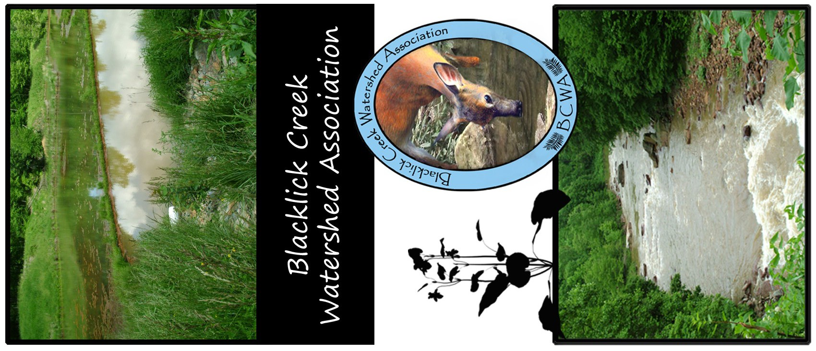

c

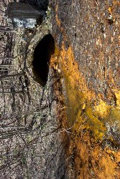
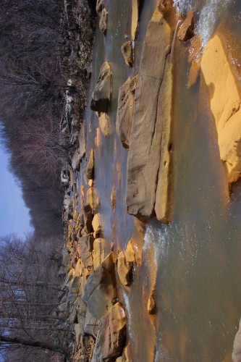
Blacklick Creek Watershed Association, Inc.
BCWA meets the 3rd Thursday of each month
E-mail: bcwapa@gmail.com for directions. For more information, visit our website at www.blacklickcreekwatershed.org.
Blacklick Creek Watershed Association
297 Sarah St Homer City, PA 15748
Financial support for this project is provided by the BHE GT&S which is dedicated to the economic, physical and social health of the communities served by Dominion companies.
This grant program was administered by the Western Pennsylvania Conservancy in commitment to its core mission of serving Pennsylvania/s
diverse ecosystems through science-based strategy, leadership, and collaboration.
Printed 6/22
Membership Application

Please enroll me as a member of the Blacklick Creek Watershed Association, Inc. in the membership category checked
.
( ) Individual $10 ( ) Business/Club/Organization $25 ( ) Lifetime Member $100 Please accept my gift of $ in support of BCWA projects. (Gifts are tax deductible. Make checks payable to BCWA)

Name Phone No.

Address City State Zip Code

email

Send to Blacklick Creek Watershed Association, 297 Sarah St., Homer City, PA 15748

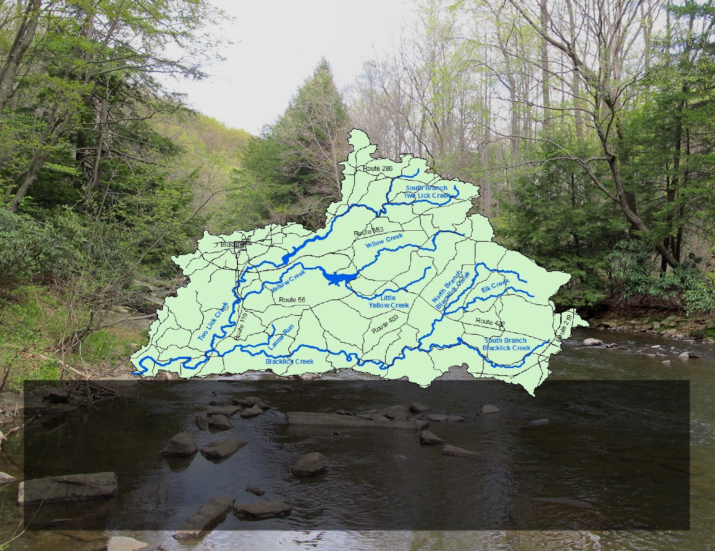
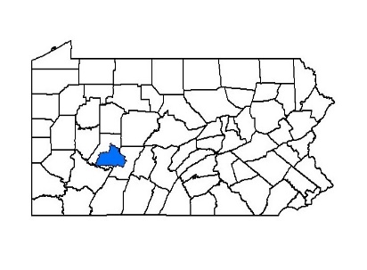

To improve stream water quality in Indiana and Cambria Counties, the Blacklick Creek Watershed Association (BCWA) was organized in 1993 as a 501©3 non-profit organization. The watershed covers 420 square miles in Western PA and is a major contributor to the Conemaugh River Drainage Basin, with the largest streams being Blacklick, Elk, Two Lick and Yellow creeks. These and other tributaries had been polluted by acid mine drainage and untreated sanitary wastewater, Today many previously dead stream segments support fish, insects and other aquatic life.

