SPRING 2021 • BCWA NEWSLETTER

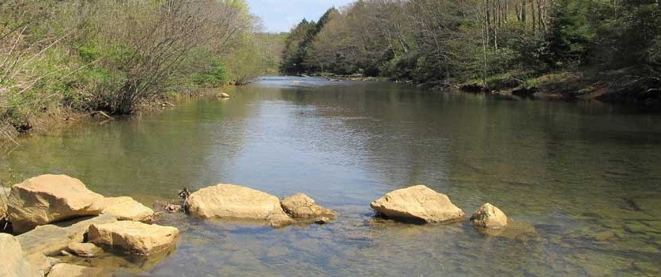
BLACKLICK CREEK WATERSHED ASSOCIATION

WHAT YOU'LL FIND INSIDE:
For more information on where
and when we meet, visit our website at www.blacklickcreekwatershed.org
Blacklick Creek Watershed
Association meets on the 3rd Thursday of each month, unless there is a holiday or other extenuating circumstance.

Page 2:
- A Destructive Invader

Page 3:
- Richards Passive System Rehabilitation

Page 4:
- ICCD Envirothon and Bags to Benches

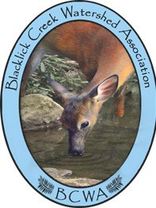
Become a Member:
Name:
Street Address:
City: State: Zip Code: Phone Number:
Email Address:
Membership Levels: Individual - $10 Family - $25 Individual Life - $100

Make check payable to: Blacklick Creek Watershed Association
297 Sarah Street Homer City PA 15748

SPRING 2021 • BCWA NEWSLETTER
YELLOW CREEK WATER SAMPLING

The Blacklick Creek Watershed Association (BCWA) partnered with the Indiana County Conservation District for a Growing Greener Grant to determine if the Yellow Creek watershed met the PA Department of Environmental Protection (DEP) Qualified Hydrologic Unit (QHU) requirements. Water quality within the Yellow Creek watershed has been significantly impacted by abandoned mine drainage.

To meet the QHU requirements, a cost/benefit analysis is conducted which is the cost of remediating of the streams verses the miles of streams that are cleaned. Several of the tributaries in the headwaters of the watershed near the Heilwood PA area, are on the Clean Water Act Section 303(d) List of Impaired Waters. After the first round of sampling of the streams and discharges, it was determined that were no significant impaired streams Most of the refuse piles have been reclaimed in that area, resulting in improved water quality Several tributaries on the List of Impaired Waters should be removed from the list since they are no longer impaired.

All of the discharges and runoff from the refuse piles are located in the area around the last three mies of Yellow Creek, between Route 954 and the confluence with Two Lick Creek. They consist of eight abandoned mine discharges, runoff from two refuse piles, an contaminated water flowing from a large borehole. However, the cost of remediating al of discharges vs the miles of stream cleaned does not meet the cost/benefit of ratio criteria.

The original plan was to sample all of the discharges, Yellow Creek at several locations and several of the tributaries quarterly for one year and that will be completed. Sampling of just the discharges for six months was added to the sampling plan to better characterize the discharges. Three quarterly sampling events and three monthly sampling events have been completed. After all of the sampling and analysis have been completed, the project consultant, Hedin Environmental, will prepare an Assessment and Restoration Plan.
A DESTRUCTIVE INVADER
The following article has been taken from several articles on various web site. To get more information, just google ‘spotted lanternfly’ and you will get an extensive list of sites which an incredible amount of details, including pictures of this invader in its various stages.

An invasive plant hopper native to China, India and Vietnam has found its way to Pennsylvania. The Spotted Lanternfly (SLF), Lycorma delicatula (White) was first discovered in Berks County and has spread to other counties in the southeast portion of the State. So put this bad actor on your watch list when you are hiking, biking, fishing, walking the dog(s) or just taking a leisurely walk through your yard or our lovely wooded areas. If you ‘google’ this insect, you will find an abundance of web sites discussing and showing pictures. A summary of some of these articles will be shared with you in this article.

This insect has the potential to greatly impact agricultural crops such as grapes, hops and hardwoods. Penn State University and Extension, US Department of Agriculture and PA Department of Agriculture have joined forces to control and contain the spread of SLF. Penn State University is leading the research efforts currently underway to answer the many questions about the insect’s biology, pesticide studies and the ability of the inset to adapt to the Pennsylvania environment.

USDA and PDA and actively treating locations where SLF has been reported. USDA is treating on the outer edges where the populations are small and will begin to move inward towards the center of the quarantine. PDA is treating areas where the population numbers are high and targeting high risk pathways which may contribute to the insect moving to other locations. PDA is also surveying all counties in the state outside the quarantine area looking for SLF.
For more FAQs about this insect, try this web site. https://spottedlanternfly.com/slf-facts-1


SPRING 2021 • BCWA NEWSLETTER
Richards Passive System Rehabilitation in Progress

Efforts to expand and rehabilitate the Richards Passive Treatment System are underway! The BCWA, Stream Restoration Incorporated (SRI), and BioMost, Inc. formed a partnership effort several years to rebuild the system. The original Richards System was designed by VAPCO Engineering and constructed in 1999 by the BCWA to treat about 150 gpm of the abandoned mine discharge from the sealed Egypt Mine, which was discharging to Two Lick Creek.

The partnership effort began when SRI was completing the Kiski-Conemaugh Basin Treatment System O&M Assessment project that had been funded by the Foundation for Pennsylvania Watersheds utilizing GenOn settlement funds. The purpose of that project was to inspect and evaluate treatment systems within the basin to determine how effective the systems are performing and identify maintenance/performance issues. This led to maintenance being conducted through SRI’s Operation and Maintenance Technical Assistance Program in 2015, 2016, and 2017. During the high flows experienced during winter and spring of 2017/2018, it became apparent that the system needed to be replaced.

The BCWA worked with SRI to find funding to complete the project. Funding has been obtained from the Pennsylvania Department of Environmental Protection’s Growing Greener Program, the US Office of Surface Mining Watershed Cooperative Agreement Program, and the Foundation for Pennsylvania Watersheds.

During the design process, it was determined that more treatment capacity was going to be needed. This required enlarging Vertical Flow Pond 1 (VFP1), combining VFP2a and VFP2b into one larger VFP2, and converting and expanding the existing flush pond into VFP3. The expansion is expected to double the treatment capability of the passive system. The existing Settling Pond 1 and Wetland are to be used essentially as is, with minor improvements. Construction began in May 2020. An effort has been made to recover and reuse old limestone from the original system. Treatment sludge and spent media is being placed in the large existing Settling Pond 1. As of December 2020, construction continues. The 3 new Vertical Flow Ponds are almost complete. The new VFPs are “Jennings-style” media consisting of gravel size limestone mixed with compost and wood chips. Once they are complete, the biggest remaining task will be installing the AMD collection and flow splitter/distribution system.

We are looking forward to completing this project to maintain and hopefully further improve the water quality of Two Lick Creek. Keep your eye out for future updates!

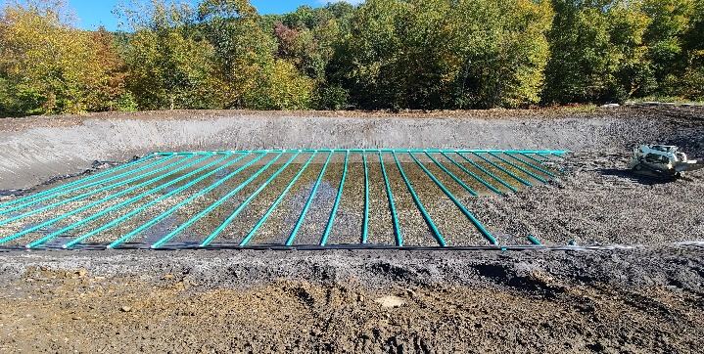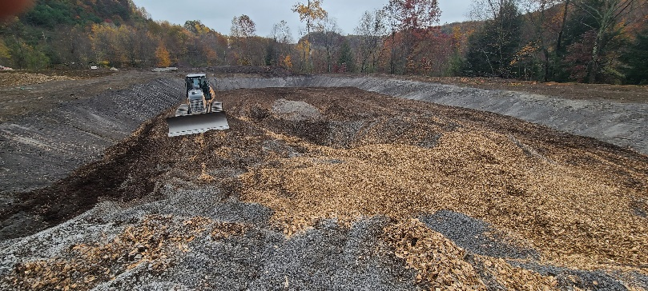

SPRING 2021 • BCWA NEWSLETTER
INDIANA COUNTY CONSERVATION DISTRICT

The Indiana County Conservation District has been awarded a grant of $2,500 through the Bork Family Fund to support its 2021 Senior Envirothon competition through the Community Foundation for the Alleghenies.

Every year the district invites area schools to send teams of students to participate in the Envirothon for the spring. The students begin to study months in advance for the competitive event. The team members participate in a series of field-oriented tests that focus on aquatic ecology, forestry, soils and land use, wildlife and a current environmental issue

The teams are tested in several ways including identifying wildlife skulls, mounted wildlife, tracks, scat, bird calls, frog calls, fish macroinvertebrates, trees, plants, insects, soil textures and soil horizons and written questions.

The stations are staffed by personnel from various partnering agencies. These agencies assist with preparing and administering tests and provide an opportunity for the students become familiar with the different organizations and agencies working to conserve and protect natural resources in Indiana County.

These organizations and agencies include Indiana County Parks and Trails, PA Dept. of Conservation and Natural Resources, Bureau of Forestry, Bureau of State Parks, Evergreen Conservancy, USA Natural Resources Conservation, PA Fish and Boat Commission, PA Game Commission and the Penn State Extension.

Each member of the winning Envirothon team is awarded a $500 David S Frick Envirothon Education Grant to be used toward post-secondary education.

The District also completed the first virtual Junior Envirothon. At the request of several teachers from various school districts, the Conservation District undertook the task of continuing the Junior Envirothon program under COVD restrictions. The staff, along with many of the great partners, developed lessons that were recorded and uploaded to YouTube for viewing by the teams. Tests were created using Google Forms that enabled teams to submit their completed tests electronically to the District.

BAGS TO BENCHES

In December 2020, the Evergreen Conservancy presented a bench to the Chevy Chase Community Center made out of 500 pounds of soft plastic bags through the Bags to Benches PROGRAM BY Trex, a composite decking company.

Bags are collected over a six-month period but the Evergreen Conservancy collected that amount in five months. The concept came to Indiana as a Boy Scout Eagle project by Silas Schiera of Troop 1011 of Indiana. Since then Horace Mann PTA and Indiana County League of Women Voters have taken up the six month plastic bag challenge.

Residents can donate grocery bags, bread bags, water case and soft drink case overwraps and newspaper sleeves. The bags need to be clean and dry. There are two locations to donate: The YMCA with a donation box outside the door, and the S&T Bank Arena with a box just inside the door.

Financial support for this project is provided by the Dominion Foundation which is dedicated to the economic, physical and social health of the communities served by Dominion companies.

This grant program was administered by the Western Pennsylvania Conservancy in commitment to its core mission of serving Pennsylvania’s diverse ecosystems through science -based strategy, leadership, and collaboration.

