SUMMER 2022 • BCWA NEWSLETTER

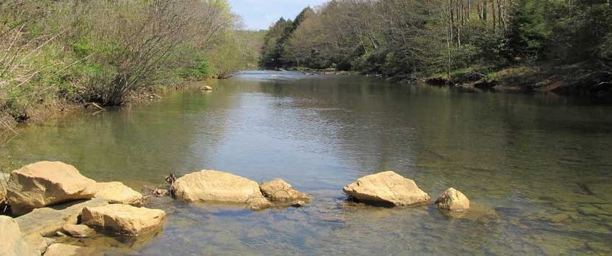
BLACKLICK CREEK WATERSHED ASSOCIATION

WHAT YOU'LL FIND INSIDE:
For more information on where
and when we meet, visit our website at www.blacklickcreekwatershed.org
Blacklick Creek Watershed
Association meets on the 3rd Thursday of each month, unless there is a holiday or other extenuating circumstance.

Page 2:

- Yellow Creek Assessment Report
- Blacklick Creek Treatment Plant

Page 3:

- Richards Passive System Rehabilitation

Page 4:

- Bags to Benches
- Vintondale Refuse Pile Removal

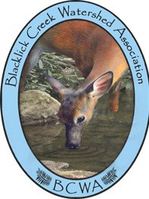
Become a Member:
Name:
Street Address:
City: State: Zip Code: Phone Number:
Email Address:
Membership Levels: Individual - $10 Family - $25 Individual Life - $100

Make check payable to: Blacklick Creek Watershed Association
297 Sarah Street Homer City PA 15748

SUMMER 2022 • BCWA NEWSLETTER
YELLOW CREEK ASSESSMENT SUMMARY

The Hedin Environmental group completed their report which was intended to update the 2005 Blacklick Creek Watershed Assessment Restoration Plan. This report included updates and details the mine drainage pollution sources in the Yellow Creek watershed, Indiana County, PA. It includes data from four mass balancing sampling efforts from November 2019 to May 2021 and monthly discharge monitoring from November 2020 to May 2021.

The report finds that the Yellow Creek is generally of good quality and able to assimilate many minor sources of mine drainage from its headwaters to about 1 mile from its mouth. At the 1-mile mark, the stream flows by the Lucerne refuse pile. This pile significantly degrades Yellow Creek to its mouth and confluence with Two Lick Creek. The source of this pollution is likely polluted groundwater.

As of 2021, the Lucerne refuse pile is being mined for burnable coal and reclaimed. Unfortunately, since the reclamation started in 1997, there is no evidence of water quality improvement in Yellow Creek.

This reort details and contextualizes the results of the mass balance and discharge sampling and offers recommendations to improve water quality.

BLACKLICK CREEK TREATMENT PLANT

The Blacklick Creek (Wehrum) treatment project will be located in Blacklick Township, Cambria County and Buffington and East Wheatfield Townships, Indiana County. The entire project area is approximately 35 acres – 28 acres of which will be previously reclaimed abandoned mine lands (AML) – and includes the conveyance system, extraction and injection wells, sludge injection wells, and treatment facility.
The goal of this project is to control and treat three major sources of abandoned mine drainage (AMD) into Blacklick Creek watershed and restore approximately 25 miles of watershed into a viable fishery to the confluence of Two Lick Creek. The three major sources of AMD that will be treated at the Blacklick Creek treatment facility are the Commercial No. 16 (Red Mill), Viton No. 6, and Wehrum Shaft. These mine water discharges will be gravity drained into adjacent mine pools prior to conveyance to the treatment plant or pumped and conveyed directly to the treatment plant that will be located in Buffington Township, Indiana County.

In April 2022, DEP awarded the $26,158,499.00 contract to HRI, Inc. Notice To Proceed was issued on June 1, 2022 and a pre-construction meeting was scheduled for June 15, 2022. Funding comes from the federal Abandoned Mine Land Economic Revitalization (AMLER) program, AMD Abatement and Treatment fund, and appropriated capital budget funds. DEP anticipates the project taking approximately three years to complete and estimates that once fully operational, the facility will be able to treat 7.2 million gallons per day prior to discharging the treated water into the main stem of Blacklick Creek.
The treatment facility is much more complex than passive treatment systems, but can treat significantly more AMD. Blacklick Creek treatment facility will incorporate a flow equalization, clarifier, reactor and sludge-holding basins/tanks together with sludge recirculating technology. Active chemical treatment is anticipated to consist of pre-aeration, hydrated lime, peroxide or other appropriate treatment chemicals. Stabilized inorganic precipitants generated during treatment are anticipated to be pumped to a portion of the Wehrum Mine.

You can find information on how the Pennsylvania Department of Environmental Protection addresses AMD, photos and videos of treatment facilities, and more on how active treatment plants work on DEP’s blog post “Acid Mine Drainage Treatment Facilities – Reversing Hundreds Of Years Of Pollution To Bring Pennsylvania’s Streams And Rivers Back To Life.”
Additional resources are available on DEP’s website:
· Acid Mine Drainage (AMD) Set-Aside Program
· Program Accomplishments
· Publications

SUMMER 2022 • BCWA NEWSLETTER
Richards Passive System Rehabilitation A Blacklick Creek Watershed Association Project
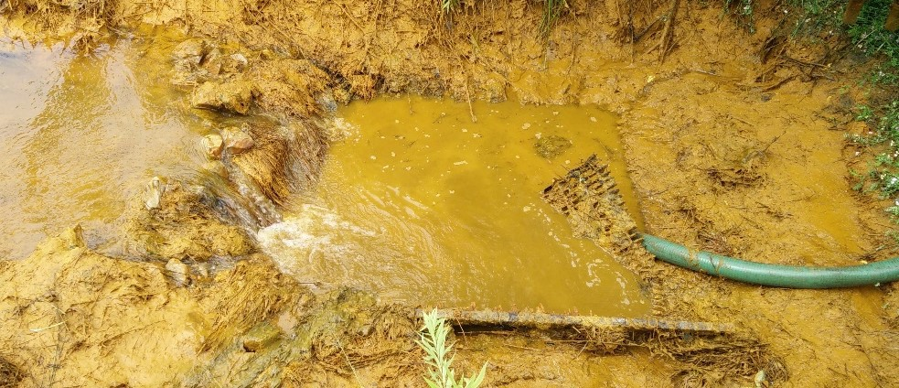
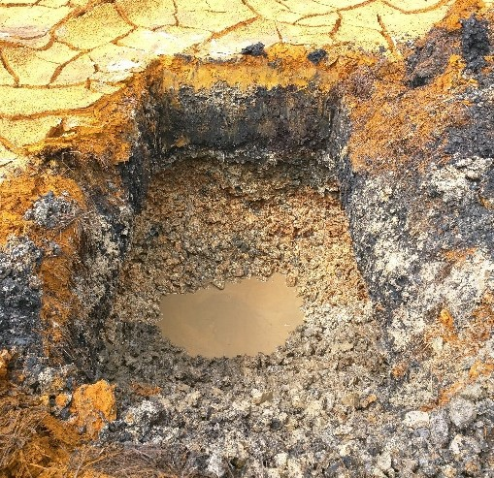
Cherryhill Township, Indiana County, Pennsylvania www.blacklickcreekwatershed.org
Before Rehabilitation: [ABOVE] The inlet system catch basin and piping often plugged causing raw water to bypass system (7/9/15); [RIGHT] Once raw water entered the vertical flow ponds, the treatment media was found to be plugged with iron and aluminum (5/23/17).

Stream Order: Two Lick Creek → Blacklick Creek → Conemaugh R. → Kiskiminetas R. → Allegheny R. → Ohio R.
Project Sponsor: Stream Restoration Incorporated (www.streamrestorationinc.org)
Problem: The existing passive system was unable to effectively treat Acid Mine Drainage (AMD) from an abandoned underground coal mine that degraded Two Lick Creek.
Goal: Rehabilitate the passive treatment system to treat the entire AMD discharge.

Project Description: The Richards Passive System was initially constructed in 1999 (Phase 1: VFR1→settling pond) and expanded between 2001 and 2003 (Phase 2: VFR2A & VFR2B→wetland). Various issues complicated system operation over the years. Defining the amount of drainage to be treated has been particularly problematic due to a lack of consistent and comprehensive flow measurement. Untreated drainage often bypassed the treatment system due to plugging issues with the collection/distribution system. Prior to the current efforts, it was determined that the three vertical flow reactors (VFRs) were plugged to the point of being unable to provide effective treatment. To eliminate inlet plugging issues, an innovative three-way flow splitting weir box was plumbed directly into the mine drain that will allow for accurate flow measurements and proportional distribution of flow. VFR1 was enlarged and reconfigured as a Jennings-type vertical flow pond (JVFP1), VFR2A and VFR2B were combined into a single, larger Jennings-type vertical flow pond (JVFP2), and the Phase 2 sludge holding basin was enlarged and reconfigured into a third Jennings-type vertical flow pond (JVFP3). JVFP1 discharges to the settling pond where an earthen directional baffle and a primary spillway pipe were added. JVFP2 and JVFP3 discharge to the wetland where PVC Z-Pile directional baffles were added and the basin was reconfigured to improve retention time. A seep encountered during Phase 2 and previously piped to the stream untreated was captured in a new French drain and piped to the wetland to mix with the alkaline effluent of JVFP2 and JVFP3. An artesian flowing corehole encountered in the wetland during Phase 2 construction continues to discharge to the final 1/3 of the wetland.

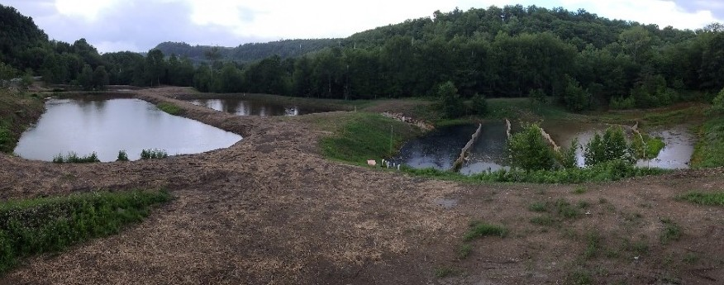
The rehabilitated system has a hydraulic capacity of 1,000 gpm and is designed to treat up to 747 gpm (max flow) with an average flow of 117 gpm. Pollutant load design capacity is 1,005 lb/day acidity, 148-296 lb/day or iron, and ~128 lb/day aluminum.

After Rehabilitation: Richards System with VFP2 (left), VFP3 (back middle) and Wetland with directional z-pile baffles (right) (7/8/21).

SUMMER 2022 • BCWA NEWSLETTER
BAGS TO BENCHES

Evergreen Conservancy continues collecting plastic in exchange for a TREX bench in
partnership with the League of Women Voters Environmental Committee of Indiana. Benches have been donated benches to Chevy Chase Community Center, The Indiana County Conservation District, the YMCA the Community Garden, and Giant Eagle (a partner in the collection). The last bench has been donated to Aging services. The plastic collection efforts will continue into future rounds. The purpose of all this is to keep plastic from going to the landfills. So the opportunity to recycle soft plastic is ongoing.

Residents can donate grocery bags, bread bags, water case and soft drink overwraps, dry cleaning bags, ice bags, wood pellet bags, Ziploc and other reclosable bags, produce bags, bubble wrap, salt bags, and cereal bags. All bags must be clean and dry.

Unfortunately, plastic bottles and all other hard plastics cannot be donated to this program. Also any bags that have metallic lining or sound really crinkly when crunched cannot be donated.

If anyone wished to support of the bags to benches project, items can be taken to the YMCA bin outside of the door or the S & T arena in the bin inside the door. Also if you have plastic you can email evergreenconservancy@gmail.com for possible pick it up, Please see www.evergreenconservancy.org/bags-to-benches-plastic-collection
for a list of what plastic can and cannot be collected.

VINTONDALE REFUSE PILE REMOVAL

The Vintondale Refuse Pile Removal project began in December 2021. To date, the contractor has removed approximately 25% of the 11-acre refuse pile which represents a public health and safety hazard to trespassers and more than 20 homes within 1,000 feet of the pile (the nearest located within 300 feet of the base of the pile). There is evidence that the pile is frequently trespassed by ATV riders. It also contributes to erosion of adjacent South Branch Blacklick Creek.

The Vintondale Refuse Pile consists of approximately 310,000 tons of coal refuse reaching 50 feet. The refuse came from Vinton Collieries’ Vinton No. 3 Mine, which ceased operations in 1906. This removal project includes removing approximately 215,000 tons of marketable refuse that will be transported to and used at a waste coal processing plant for energy. The remaining refuse will be regraded on site in a manner that will prepare the site for a recreational trail head (900 linear feet) and community greenspace with gravel parking lot with capacity for 25 vehicles. Final grading will incorporate alkaline fly ash material into the refuse to promote vegetation growth. DEP anticipates that the project will lead to the improvement of approximately 22 stream miles once the project is complete.

The $396,500 contract was awarded to Robindale Energy Services, Inc, and it has until June 26, 2024 to complete the project. The project is currently proceeding on schedule.

Financial support for this project is provided by the BGH GT&S which is dedicated to the economic, physical and social health of our local communities.

This grant program was administered by the Western Pennsylvania Conservancy in commitment to its core mission of serving Pennsylvania’s diverse ecosystems through science -based strategy, leadership, and collaborators

